**TECH TIPS FOR HCC STUDENTS**

**HCC Distance Learning Coordinator/Blackboard Admin:**Jon Reidford  
[jon.reidford@kctcs.edu](mailto:jon.reidford@kctcs.edu)  
270-831-9829

**HCC Technology Solutions Help Desk**  
270-831-9616  
  
**Online Student Resources:**  
<https://henderson.kctcs.edu/current-students/academic-resources/online-student-resources.aspx>

|  |  |
| --- | --- |
|  | **GoKCTCS! Student Service Center (evenings/weekends)**  855 GO-HCC44 (855-464-2244) |

**Accessing MYPATH:**

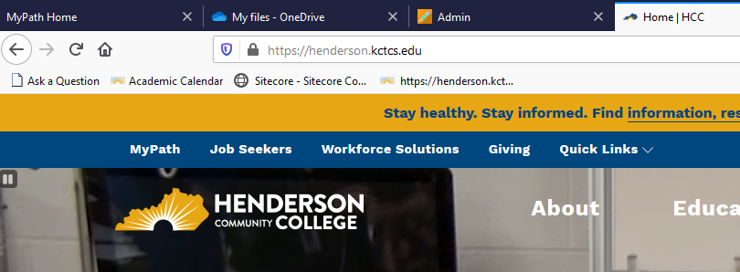  
**HCC > Current Students > MYPATH >**

* Blackboard
* Email
* PeopleSoft Campus Solutions
* Library (database access, etc.)
* User Account Center (make sure personal email, etc. is listed in event of password issue)
* OneDrive *(always good to have a flash drive also!!!)*
  + Use OneDrive to backup schoolwork and also use to house large files to share (videos/audio) with instructors and classmates

**Using ONEDRIVE:**

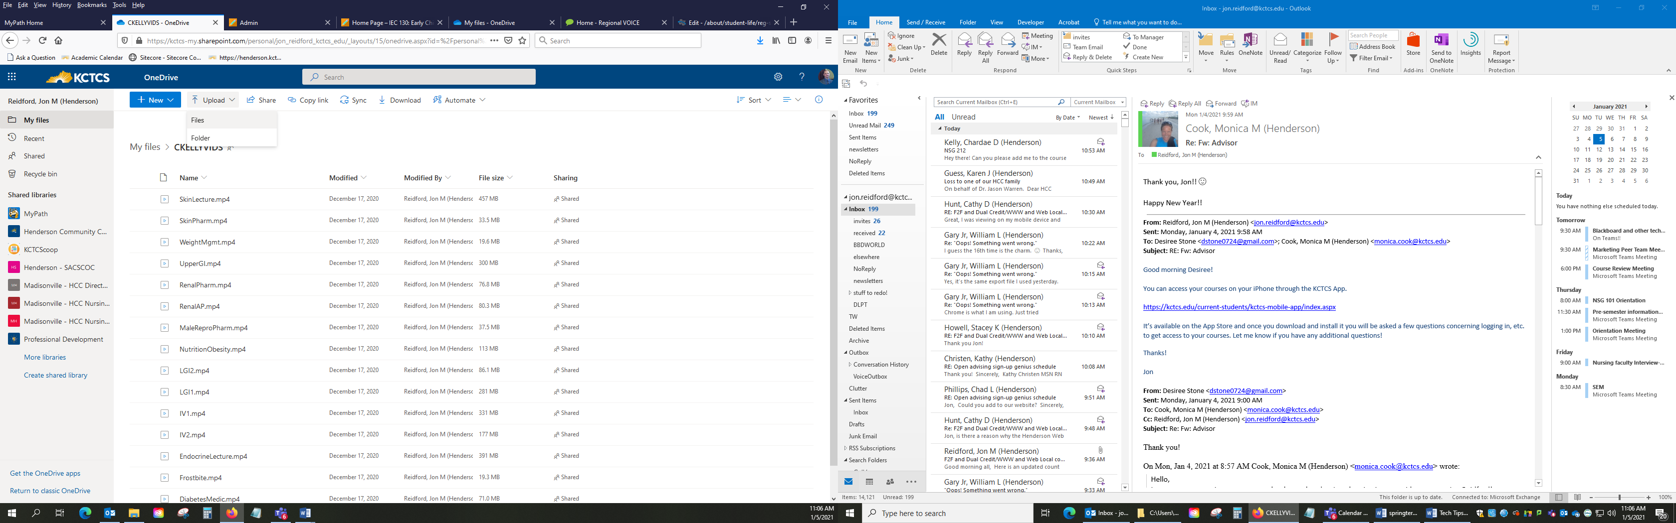

Above, click the **Upload** link to add a file(s) or folder to your OneDrive area.

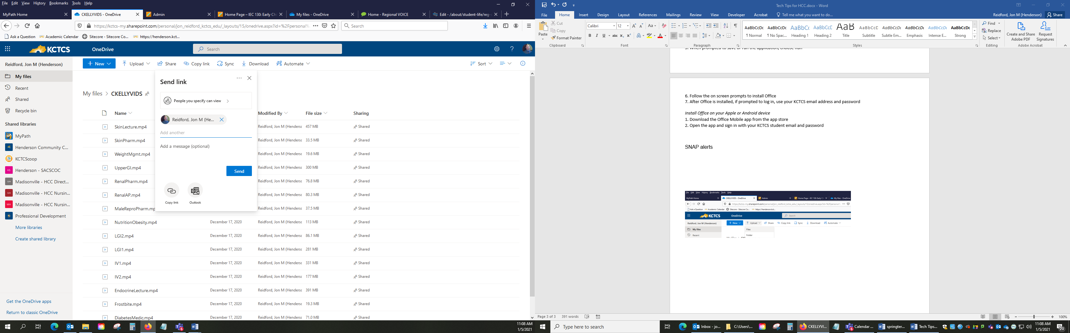

Next, to share a file with an instructor or classmate click on **Share** and then type a name(s) in the **Add** area and you can also create a message below that as well. Click **Send** when ready!

**Access Blackboard via** **MyPath OR via** [**http://elearning.kctcs.edu**](http://elearning.kctcs.edu)

**Blackboard Student Institution Page** > Announcements and Student Resources **Blackboard Notifications/Activity Stream** (set filters to show messages, announcements, calendars, etc.)  
  
***\*remember all Blackboard-generated times are EST by default***

***\*remember to close out of your HCC account/Blackboard on public computers***

**Clearing cache and history from Internet browser:  
  
Google** recommended browser settings:

Google – Settings – Advanced – Clear browsing data –

Google – Settings – Advanced – Privacy & security – Popups/redirects – Allowed

Google – Settings – Advanced – Site Settings – Cookies (Allow sites to save….)

**Firefox** recommended browser settings:

Firefox – IIII\ History menu – Clear Recent History

Firefox – (hamburger icon) History – Clear when Ff closes

Firefox – (hamburger icon) Cookies and Site Data – Accept cookies and site data (recommended)

Firefox – (hamburger icon) Permissions – Uncheck Block pop-up windows (Exceptions: henderson.kctcs.edu and elearning.kctcs.edu)

**Downloading OFFICE 365**

All KCTCS students who are currently enrolled in a course are eligible to install the full version of Microsoft Office 365 Pro Plus on up to 5 devices for free!  This includes PC, Mac, Apple tablets and phones, and Android tablets and phones.  The software will continue to work as long as you are enrolled in at least one class at a KCTCS college.

Get your discount now at <https://www.office.com/?auth=2&home=1>.  
  
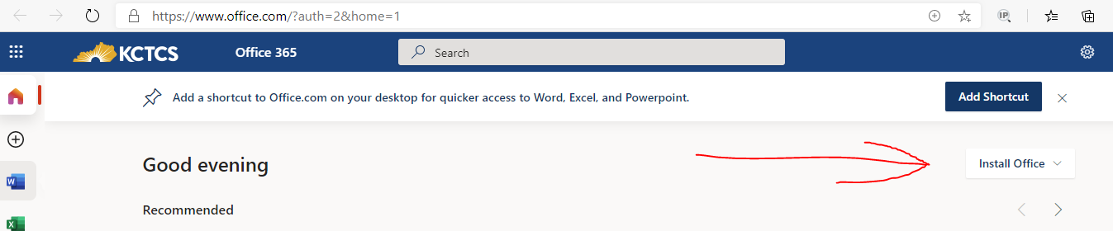

**Instructions:**  
  
Install Office on your PC or Mac  
1. Sign in with the KCTCS account, then click the “Install Office” button located on the right (see above). That then downloads the installer.  
2. When prompted to save or run the application, choose Run  
3. Follow the on screen prompts to install Office  
4. After Office is installed, if prompted to log in, use your KCTCS email address and password

Install Office on your Apple or Android device  
1. Download the Office Mobile app from the app store  
2. Open the app and sign in with your KCTCS student email and password

**Receive SNAP alerts!**[https://kctcs.edu/about/safety-security/snap/index.aspx](https://nam10.safelinks.protection.outlook.com/?url=https%3A%2F%2Fkctcs.edu%2Fabout%2Fsafety-security%2Fsnap%2Findex.aspx&data=04%7C01%7Cjon.reidford%40kctcs.edu%7Ca24c7b949bc44fc3316e08d8b3feedff%7Cf2e339511ec44c72b2bfa4f4671d64af%7C0%7C0%7C637457254799603848%7CUnknown%7CTWFpbGZsb3d8eyJWIjoiMC4wLjAwMDAiLCJQIjoiV2luMzIiLCJBTiI6Ik1haWwiLCJXVCI6Mn0%3D%7C1000&sdata=GZAfPD%2F6lyd%2FFaxiEC7qjF3EsZmYiwWvw3p1ySRtI2U%3D&reserved=0)

Sign into Peoplesoft to complete the install process. Find out if classes are cancelled or delayed due to weather, power outages or other unexpected events impacting campus. Get severe weather notifications so you can take shelter when a storm hits. Receive emergency messages when something or someone could be a threat to your personal safety.

**GET CLOSE CAPTIONING IN YOUR BROWSER FOR STREAMING CONTENT:**

**Activate this link in Google Chrome**: <chrome://flags/#enable-accessibility-live-captions> (Then go to Settings/Advanced to click to activate)