HCC Career Services Angie Watson, 831-9671
STC 213
Angie.watson@kctcs.edu

The Resume & Cover Letter

Workbook

TABLE OF CONTENTS
Chapter 1: Introduction 3
What is a Resume and How to Use It 3
Chapter 2: Before you Start Writing Your Resume 3
Brainstorm 3
Review Job Posting or Job Description 3
Chapter 2: Resume guidelines and formats 4
Appearance 4
Font 4
Paper 4
Length 5
Resume Writing Style 5
Resume Mistakes 5
Resume Formats 5
Chronological 5
Combination/Hybrid 6
Functional 7
Chapter 4: Writing the resume 7
Typical chronological flow: 7
Header 8
Objectives 8
Summary 8
Self-Descriptive Words 10
Technical Skills 10
Education 11
Work or Professional Experience 11
Transferable Skills 12
How to Write a Job Scope: 13
How to Write an Achievement: 13
Powerhouse Action Verbs 15
Optional Sections 16
Tips for a Computer-Friendly Resume 17
Chapter 5: References 18
Chapter 6: Cover Letters 20

Parts of a Cover Letter 20
Constructing a Cover Letter 20
Addendum 1: Sample Summaries 22
Addendum 2: Sample Resumes 25
Addendum 3: Sample Cover Letters 31
Resume Worksheet 33

CHAPTER 1: INTRODUCTION

WHAT IS A RESUME AND HOW TO USE IT
A resume is a marketing tool. You use it to sell yourself to a company. It shows off achievements, attributes, strengths and culmination of expertise to show how you will add value to the organization. It never contains negative information or weaknesses. The primary purpose of the resume is to obtain an interview.
Use a Resume to…

- Respond to a job posting or ad
- Give an employer more information about you than the job application gives
- Send to a company for which you’d like to work
- Give to an interviewer so he or she will ask you about the achievements listed on your resume that you want to discuss.

CHAPTER 2: BEFORE YOU START WRITING YOUR RESUME
BRAINSTORM
- List everything you have done professionally and academically.
- List volunteer work, awards
- List awards or special recognitions
My List
- Soup Kitchen Volunteer – St. Anthony’s Church 2016-Present
- Secretary, Webster County High School History Club – 2016
- Environmental Services Specialist, Methodist Hospital 2017 - Present
- Fluent in Spanish
- Perfect Safety Award 2017, Methodist Hospital
REVIEW JOB POSTING OR JOB DESCRIPTION
If you don’t have a job description or job posting, you can Google: “sample job description of (job title)”.

- Highlight skills needed
- Highlight keywords used
- Compare your experience and education with the job requirements.

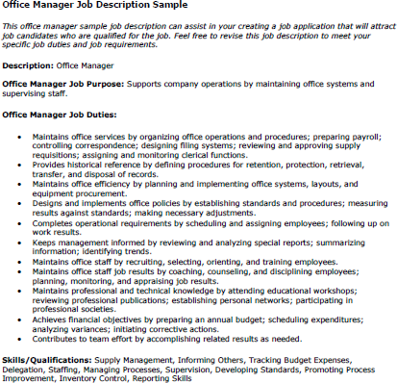
tify skills needed and your skills
Iden

CHAPTER 2: RESUME GUIDELINES AND FORMATS
APPEARANCE
- Is inviting and easy to read; not too much information
- Incorporates enough white space between sections to facilitate skimming
- Use actual numbers “10” instead of “ten”. Using numbers rather than words cause the eye to pause while reading. This allows the reader’s brain to absorb what you’ve written
- Present information uniformly and in alignment
- If you decide to use a template, customize it so that it reflects your individual style and contains specific information relevant to the position you are applying for.

FONT
Uses appropriate Times Roman or Arial fonts between 10-12 pts. (font size)

PAPER
- Use 8.5 x 11 paper.
- Use neutral color paper
- Print on one side only.

LENGTH
Rule of Thumb:

- 1 PAGE – for those with less than 3 years’ experience
- Up to 2 PAGES for those with 3+ years’ experience

Everyone has heard the advice that you should keep your resume to one page. That is no longer true. Remember, the purpose of a resume is to sell you. If you need to go to two pages, go ahead. For those with publications, presentations, or speaking engagement, you could have a third page for an Addendum.

RESUME WRITING STYLE
- Edit your core resume for each position
- Use keywords found in the position description
- Begin sentences or phrases with powerful action verbs. Watch your tenses!
  - Use Present tense verbs for current position
  - Use Past tense verbs for previous positions
- Avoid complete sentences – eliminate unnecessary or extra words such as a, an, the
- Avoid paragraphs as your important information will get lost in a paragraph
- Proofread and insure resume is free of spelling, grammatical, and typographical errors. (Don’t count on your computer’s spell check to catch everything. Do thoroughly proofread it at least once after printing it.)

RESUME MISTAKES
- Use the word RESUME on the top
- Put a photo or any pictures on it
- List any “personal” info on it such as age, race, religion, health, marital status, children, hobbies, social security number, height, weight)
- List reasons for leaving
- List your salary history in the resume
- Use many different fonts or typeface styles
- State “References Upon Request” or list references
- Use personal pronouns such as I, me, my, our, or their
- Use “Responsibilities include…” or “Duties Include…” (we don’t want your resume to sound like a job description) Remember, it’s a sales brochure!
- Use inappropriate or unprofessional email address.
- Use your work email or phone number as contact information. Employers don’t want to know you are using another employer’s time to look for a position.

RESUME FORMATS
CHRONOLOGICAL
- Presents resume with most recent experience first
- Generally preferred by most HR and decision makers
- Used if majority of work experience/education relates to target position

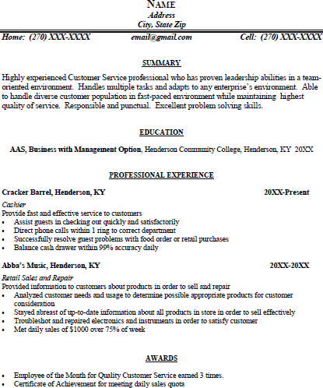

Most recent experience first

2nd most recent experience 2nd and so on.

COMBINATION/HYBRID
- Highlights skills or areas of expertise relevant to job requirements
- Provides chronological work history after highlighted accomplishments that employers prefer.
- Typically used for career changers
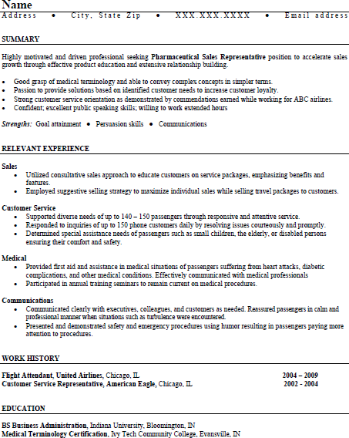
Skills Are Highlighted Relevant to the Position

FUNCTIONAL
- Focuses on skills and experience.
- Eliminates work history.
- Typically use for those hiding gaps in their employment history
- Can be used for those with no experience at all, but chronological resume is preferred.

CHAPTER 4: WRITING THE RESUME
TYPICAL CHRONOLOGICAL FLOW:
- Header - Contact Information
- Summary
- Technical Skills (if applicable for IT students)
- Education**
- Work Experience
- Optional Sections such as Military Experience, Volunteer Experience, Professional Development or Affiliations, Awards/Honors

** For individuals who have been out of school for more than 3-5 years of experience, move your Education section below the work experience as your work experience now needs to standout.

Below are the details of each of the sections listed above. Keep in mind these are only suggestions and every resume written is different.

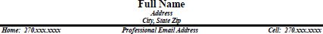
HEADER

- Do not place “RESUME” at the top of the page.
- Use your full name
- Use a current address and phone number
- Place your name on the left and page number on the right on the 2nd page of your resume provided it goes on to a 2nd page.

OBJECTIVES
Notice that there is not a section called “Objective” in the list above. Objective statements are outdated and have been replaced by a summary section. A well-positioned summary will inherently communicate your objective along with your knowledge, expertise, strengths and value you can add to the organization, therefore a separate objective statement is not needed.

SUMMARY
Even though this section comes first on your resume, write it last. Writing the rest of your resume and identifying your achievements and skills will help you write this section. Below this section is a list of self-descriptive words to review and help you write a more professional summary. Sample summaries are in Addendum 1.

A Summary tells the reader “Who YOU are and what YOU can do”. It has four elements:

- Who are you professionally?
  - Your target job title and experience!
- What are your functional/hard skills?
  - What you do well!
- What are your strengths and abilities?
  - How you do things!
- What type of contribution will you make?

  - How you will add value

Below are the elements with examples highlighted by italics:

- Who are you professionally (job title)? Examples: Bookkeeper, Computer Programmer, Clinical Lab Technician
Who are you professionally highlighting your experience including Industry experience?

  - Marketing professional with over 2 years’ experience in product merchandising, sales, and customer relations.
  - Bookkeeper with A/R and A/P internship experience in manufacturing industry.
  - Cheerful and detail-oriented Registered Dental Hygienist with education and experience in oral hygiene dental treatments.
- What are your functional/hard skills? What you learned on the job/volunteer work that relates to the target job that you do well.
  - Profound knowledge of machines and tools, including their uses, repair, and maintenance
  - Special expertise in patient management and making patients of all ages feel as relaxed and comfortable as possible, relieving any anxiety or tension they might have.
  - Experience and education in business and human resources including interviewing, record-keeping, and maintenance of employee files.
- What are your strengths and abilities?
  - Communicates effectively with diverse clientele utilizing sound judgment and self-motivation.
  - Ability to communicate technical issues with non-technical people.
  - A team player who is attentive to detail and produces quality results.
  - A self-starter and capable of effectively functioning with minimum supervision
- What type of contribution will you make? How will you add value?
  - earned a reputation for priority setting and team building.
  - …taking pride in creating efficiencies while maintaining quality results.
  - Known for taking initiative and skilled at meeting challenges and deadlines.
Summary

Financial professional who is a self-starter and capable of effectively functioning with minimum supervision. Known for taking initiative and skilled at meeting challenges and deadlines. A team player who is attentive to detail and produces quality results.
Computer proficient. Areas of expertise include:
- Analysis
- Detail Oriented
- Accounts Payable/Payroll
- Multi-Tasking
- Microsoft Office
- Organization/Prioritizing
- Written /Verbal Communications • Data Entry

Network Technician with a passion for problem solving to insure customer satisfaction. Experience with setting up, testing and debugging network. Known for configuring, testing and troubleshooting narrowband systems and broadband systems. Plans, organizes, and prioritizes assigned projects with ability to balance multiple tasks.
Communicates technical issues to non-technical people.

SELF-DESCRIPTIVE WORDS

Active | Determined | Independent | Realistic
Adaptable | Diplomatic | Logical | Reliable
Aggressive | Disciplined | Loyal | Resourceful
Alert | Discrete | Mature | Respective
Ambitious | Economical | Methodical | Self-reliant
Analytical | Efficient | Objective | Sense of humor
Attentive | Energetic | Optimistic | Sincere
Broad-minded | Enterprising | Perceptive | Sophisticated
Conscientious | Enthusiastic | Personable | Systematic
Consistent | Extroverted | Pleasant | Tactful
Constructive | Fair | Positive | Talented
Creative | Forceful | Practical | Will travel
Dependable | Imaginative | Productive | Will relocate

TECHNICAL SKILLS
This section is typically reserved for IT professionals who want to highlight specific technical skills like the languages they use, operating systems, etc. Below is an example:
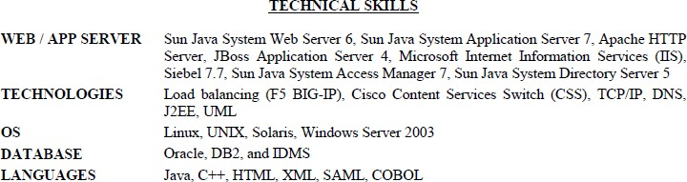

EDUCATION
- List the type of degree you have or will receive, your major, then the name of the school/college, then city and state.
- If you have received several degrees, list the highest degree first.
- If you are receiving or have received a college degree, it is not necessary to list your high school or GED education.
- It is not necessary to list higher educational institutions that you attended, but did not graduate from unless the credit hours you earned are relevant to the target position.
- List training, seminars, certifications. If you are a new or recent graduate:
- List coursework or projects that are relevant to the position.
- List your GPA if it is 3.0 or higher.
- List their graduation year. After 3-5 years, remove to keep your resume ageless.

EDUCATION HISTORY
Diploma, Henderson County High School, Henderson, KY 2012

JOB SPECIFIC TRAINING AND QUALIFICATIONS
Microsoft Certification (75% completed) HONORS, AWARDS, AND SPECIAL ACCOMPLISHMENTS
Perfect attendance record since 2016
Recognized by management for “Special Customer Service Award”

WORK OR PROFESSIONAL EXPERIENCE
The Work Experience section is a summary of your work experience and accomplishments that focuses on the past 10- 15 years. Work experience older than 15 should probably be eliminated. Why? If you haven’t used the skills in the last 10-15 years, employers will typically think your skills are out-of-date or very rusty.
Describe your work experience even if it is not relevant to your target position because employers are looking for skills that are transferable, commitment, and responsibility. Include full-time and part-time employment. List volunteer experience if it relates to the job and that avoids a possible bias. We don’t want anything in your resume to possibly offend a reader and thus eliminate your resume. Internships, co-op experience or externships should also be part of

your work experience. Any experience that highlights your achievements and reflects well on you as solid candidate should be included.
Tips:

- Adapt your resume towards your target job.
- Write achievements that emphasize your hard and soft skills that are transferable to your target position.
- List your most important achievement first.
- List the company name, city and state, and the dates (in years) that you worked there.
- List only years. This gives your sales brochure a cleaner presentation. The Employment Application is the place for the details of your actual months/years of employment.
- A suggestion is to put your dates of employment on the right side of the page, so as not to give more emphasis to the dates. Readers read left to right and we want the most important information to go on the left. Dates are not as important as the Company and Job Title in your sales brochure.
- List your job title or job role, and then define it further with a job scope definition.
- Finally, you will list achievements using bullet points. Each achievement must start with a powerhouse action verb and have 2 elements:
  - ACTIONS – how you did the achievement
  - RESULTS – the outcome or why you did the achievement. Quantify your results if possible.
  - Rule of thumb: you should have 1 achievement for every year in a position.
- Numbers sell. Use numbers where ever you can. Instead of “trained employees” say “trained 5 employees”.

TRANSFERABLE SKILLS

The National Association of Colleges and Employers (NACE) is a professional association that connects more than 5,200 college career services professionals at nearly 2,000 college and universities nationwide, and more than 3,000 HR/staffing professionals focused on college relations and recruiting. NACE has compiled the twenty (20) top personal qualities/skills that employers requested the most:

1. Analytical Skills | 11. Leadership & Management Skills
2. Communication skills | 12. Motivation & Initiative
3. Computer skills | 13. Organizational & Time Management Skills
4. Creativity | 14. Real Life Experiences
5. Detail-oriented | 15. Self-Confidence
6. Entrepreneurial skills/Risk taking | 16. Strong Work Ethic
7. Flexibility & Adaptability | 17. Tactfulness
8. Friendly & Outgoing personality | 18. Team Player (works well with others)
9. Honesty/Integrity | 19. Technical Skills
10. Interpersonal Skills (relates well to others | 20. Polite & Well-Mannered

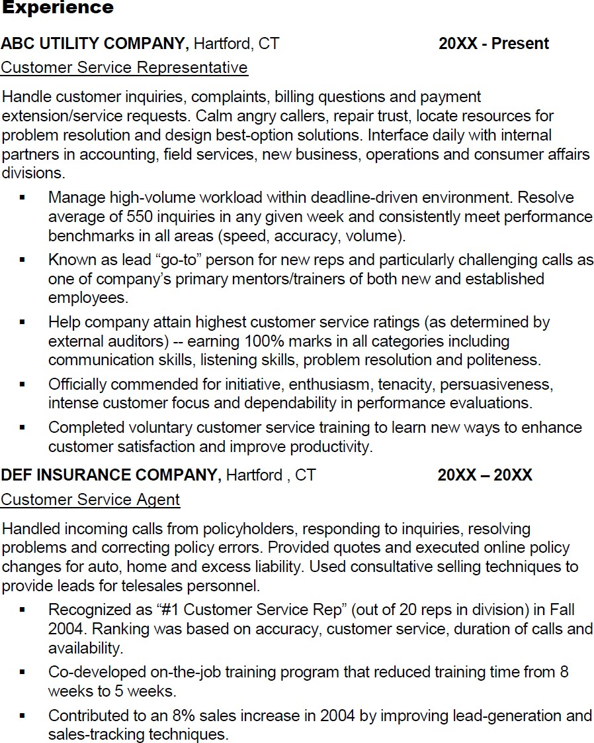
HOW TO WRITE A JOB SCOPE:
Achievements
Achievements
Job Scope
Job Scope
The job scope is typically 1 – 5 lines that tell the reader what your overall responsibility was in the position. It defines your role. Always lead with an action verb (listed in a section below). Include your job dimensions, range, staff size, budget and reporting relationship, if it’s relevant.
HOW TO WRITE AN ACHIEVEMENT:
To set yourself apart from other candidates, you need to eliminate a list of responsibilities which are typically just job duties or actions you took. Instead you want write specific achievements for your positions. They demonstrate the "value" of your work to previous employers. Achievements have two elements:
ACTIONS (what was done) + RESULTS (measurable outcome)

Can you see the difference? Responsibility: Operated cash register
Accomplishment: Operated and balanced cash register (ACTION) with 100% accuracy (RESULTS).

Responsibility: Designed maintenance programs.

Accomplishment: Designed and implemented preventative maintenance program (ACTION) that reduced equipment downtime by 20% and significantly increased order processing (RESULTS).

Responsibility: Bought office supplies
Accomplishment: Saved $5,000 annually on office supplies (RESULTS) by negotiating with outside supply company for best prices (ACTION).

Achievements can be difficult to write, so to help you. Here’s another way to look at it:
- Conducted training programs.
Poor

Okay
- Conducted many training programs in several states
which reduced problems.

Better

Conducted more than 30 customer service training programs throughout tri-state region reducing customer complaints by 15% in 3-month period.

BEST

Reduced customer complaints by 15% in 3-month period by conducting more than 30 customer service training programs throughout tri-state region.

The BEST example starts with the RESULTS and ends with the ACTIONS taken. Remember, the most important information should start on the left as we read left to right.

Use the Powerhouse Action Verbs below to help you write your achievement. Your achievements should answer:

- How you did “X”
- Why you did “X”

Employers want to see how your achievements affect the bottom line of a company:
- How did you save the company money?
- How did you increase profits?
- How did you reduce costs or waste?
- How did you create efficiencies? Did you identify and/or implement a more efficient way of doing a procedure or something in the office?
- How did you save time or reduce downtime?
- How did you go above-and-beyond or go that extra mile at school or at work?
- How did you solve a major problem?
- How did you provide exceptional customer service? Did you have a reputation for handling certain difficult problems, situations or people?
- How did you bring in new customers/business?
- How did you reduce errors?
- How did you improve performance?
- How did you organize something?

POWERHOUSE ACTION VERBS
- The words that you use to describe your experience, activities and other categories also convey the skills that you have developed and what you have to offer an employer.
- Using these t powerhouse action verbs evoke confidence and authority and gets the employer’s attention. Start each accomplishment statement (bullet point) with a powerful action verb like these:
accomplished | computed | established | instructed | produced | summarized
achieved | conceptualized | evaluated | integrated | programmed | supervised
acted | conducted | examined | interpreted | projected | surveyed
adapted | consolidated | executed | interviewed | promoted | systemized
addressed | contained | expanded | introduced | provided | taught
administered | contracted | expedited | invented | publicized | trained
advanced | contributed | explained | launched | published | translated
advised | controlled | extracted | interviewed | recorded | traveled
allocated | coordinated | fabricated | introduced | recruited | trimmed
analyzed | corresponded | facilitated | invented | reduced | upgraded
appraised | counseled | familiarized | launched | referred | validated
approved | created | fashioned | lectured | regulated | worked
arranged | critiqued | focused | led | rehabilitated | wrote
assembled | cut | forecast | maintained | remodeled
assigned | decreased | formulated | managed | repaired
attained | delegated | founded | marketed | represented
audited | demonstrated | generated | mediated | researched
authored | designed | guided | moderated | restored
automated | devised | headed up | monitored | restructured
balanced | diagnosed | identified | motivated | retrieved
budgeted | directed | illustrated | negotiated | revitalized
built | dispatched | improved | operated | saved
calculated | distinguished | increased | organized | scheduled
catalogued | diversified | indoctrinated | originated | schooled
chaired | drafted | influenced | overhauled | screened
clarified | edited | informed | oversaw | set
classified | educated | initiated | performed | shaped
coached | eliminated | innovated | persuaded | solicited
collected | enabled | inspected | prepared | specified
compiled | encouraged | installed | presented | stimulated
completed | engineered | instigated | prioritized | streamlined
composed | enlisted | instituted | processed | strengthened

OPTIONAL SECTIONS
You can add one or several sections based on what you want the employer to know about you that “adds value” to your career objective or goal. Possible sections are:

- Special Skills
- Professional and Community Affiliations
- Honors and Awards
- Military Experience
- Honors

A word about Awards: For those individuals who have work experience that have won awards for their work. It is more impressive to show how you earned your award in the actual work experience rather than a separate “Awards” section.
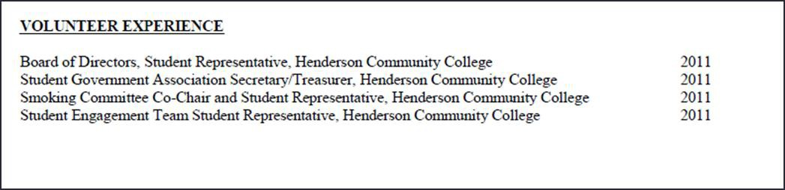
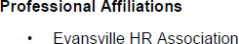
Honors

- Recognized for Outstanding Business Marketing Project, 2017
- Elected President, Student Government Association, 2017

Special Skills

- Bilingual in Spanish and English
- Certified in CPR
- Expertise in creating macros in MS Excel

TIPS FOR A COMPUTER-FRIENDLY RESUME
If you are uploading a resume to a website or job search engine or into the body of an email create a plain text of your resume. A text resume is a version of your resume without formatting – without bullets, bold text, italicized text, tabs or elaborate fonts. Use these instructions to complete a text resume:

- Open your resume in Microsoft Word.
- Under file, choose "Save as" - you are going to create a new document out of the original resume document.
- On the resulting screen, name your text resume in the space provided for "File name" and choose "plain text" in the "Save as type" option. If you encounter a warning screen, click “OK.”
- Close your formatted resume (Word). Find and open your new text document from the location where you saved it. You will note that it exists as a notepad (.TXT) document.
- In text form, the resume will be without bold/underlined/italicized text, bullets and tabs. Without these elements, the resume is now closer to machine code and may be read as data.
- To make the resume more easily legible, go under "Format" and choose the "Word Wrap" function. This will ensure that your words are arranged properly at the end of each line rather than being abruptly cut.
- Scroll through your text resume and use the space bar and the "Backspace" and "Return" keys to shape your resume to your satisfaction. Be sure to eliminate any odd spacing that might have occurred during translation. While you cannot use formatting options like bold text or bullets, you can use asterisks for bullet substitutes and space to separate different sections and headings.

Sample resumes are in Addendum 2.

CHAPTER 5: REFERENCES

A reference is someone who can and will vouch for your capabilities, skills, and suitability for a job. References can be your instructors, coaches in school or your managers or co-workers in your more recent paid or volunteer employment. Relatives and classmates are not appropriate references.

Your references play a critical role in helping you to move to the final offer, yet many job seekers don’t give their full attention to this part of their references.
  - Select your references carefully. Choose people who are interested, engaged, and will endorse your strengths and contributions enthusiastically.
  - Choose the appropriate number of references. Choose 4-6 references that know you professionally and have worked with you in the past.
  - ASK THERE PERMISSION BEFORE listing them as a reference. Approach your references and ask if they are willing to be a reference for you.
  - Verify their contact information. Ensure you have their most current job title, company, and address. Ask what phone number and email that they prefer you publish on your reference list.
  - Prepare your references to best represent you. Your references should be able to clearly articulate your value to a potential employer.
  - Keep them informed of your search progress. Be sure to keep your references updated on your job search so they are continually prepared to speak on your behalf.
  - Follow-up to find out if the reference was contacted and how it went

IMPORTANT NOTE: The reference sheet is NOT something you attach to your resume. It is only given to the employer when asked for references.

Sample Reference Sheet is on next page.

NAME
Address City, State, Zip
Home: (xxx)xxx-xxxx email address Cell: (xxx)xxx-xxxx

References

Use the same "Header" used on your resume to maintain a consistent, professional appearance. Reference details should include:

Name
Current Title (if employed) Current Company Name Address
Anytown, Anywhere Zip Telephone number
E-mail address
Relationship to you (i.e. Former Supervisor, Former Customer, Former Vendor)

Name
Current Title (if employed) Current Company Name Address
Anytown, Anywhere Zip Telephone number
E-mail address
Relationship to you (i.e. Former Supervisor, Former Customer, Former Vendor)

Name
Current Title (if employed) Current Company Name Address
Anytown, Anywhere Zip Telephone number
E-mail address
Relationship to you (i.e. Former Supervisor, Former Customer, Former Vendor)

Name
Current Title (if employed) Current Company Name Anytown, Anywhere Zip Telephone number
E-mail address

CHAPTER 6: COVER LETTERS

PARTS OF A COVER LETTER
- INTRODUCTION: The first paragraph tells why you are writing. It identifies the employer and position by name, and conveys how/where you found the job lead.
- YOUR MARKETABLE SKILLS: The second section tells how your background, experience, and skills are related to the target job.
- YOUR “CALL TO ACTION”: The third paragraph is your close: what do you want to happen next?
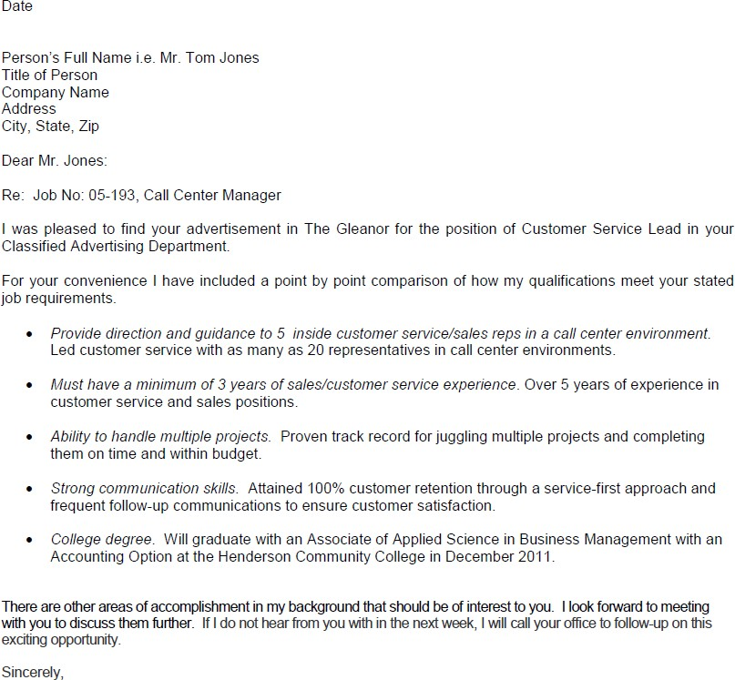
Introduction

Your marketable skills
Your "call to action"
CONSTRUCTING A COVER LETTER
  - Always use standard cover letter protocol. Just because it’s an email doesn’t mean you should abandon standard business letter writing. Make sure to include a salutation (Dear Ms. Roth) and a standard closing (such as Sincerely or Yours truly). Leave blank lines between paragraphs. Avoid using emoticons, abbreviations, wild colors, etc.
  - Take advantage of keywords. Use keywords pertinent to the job you are seeking, and focus on key industry buzzwords and critical skill sets.
  - Don’t waste your subject line. Don’t ever leave the subject line of your email blank. Use the subject line to entice the reader into your cover letter. If you are applying to a specific position, mention the job title for easy reference.
  - Justify your left-hand margins. Avoid indenting and other formatting devices because formatting is often altered in electronic transmission.

  - Never hit “send” without thoroughly spell checking and proofreading your email cover note. Don’t just rely on your email software’s spellchecker. Take the time to really proofread it. A simple typo could undermine a brilliant cover letter.
  - Be sure to test your message before sending it to the company. Even if you’re sure your letter is perfect, send it to a friend or another one of your e-mail accounts first and check for the content and style one more time.

Sample Cover Letters in Addendum 3:

ADDENDUM 1: SAMPLE SUMMARIES

PROFILE

Enthusiastic and fresh Registered Nurse (RN) with particular experience in mental health unit. Developed well-built psychiatric-assessment and treatment-planning skills through current internship at Houston Department of Corrections. Aptitude to stay peaceful in urgent situations. Intervene during emergency, facilitates groups and learning seminars, and collaborates on multidisciplinary teams. Demonstrated ability to build constructive relationships with patients, family members, physicians and other health professionals.

CERTIFIED MEDICAL ASSISTANT

CMA with experience in a multi-physician family medical practice and additional healthcare experience as an RPT. Known for dedication to providing premium patient care. Skills include:

- Medical Office Management  - Medical Billing & Coding  - Medical Records Management  - Data Entry (75 WPM) | - Bookkeeping & Filing  - Taking Patient Vitals  - Blood Draws  - Injections | - Patient Scheduling  - Ancillary Testing  - Patient Education  - HIPAA & JCAHO Knowledge

SUMMARY
BOOKKEEPER • ACCOUNTS PAYABLE / ACCOUNTS RECEIVABLE OFFICER

Knowledge seeker, keen to maximize own professional value by learning and committing to full-time employment engagements. First-rate communicator, self-regulating worker. Acknowledged for capacity to meet deadlines, "get the numbers right," resolve persistent problems, and conceive cost and efficiency improvements for financial well-being of business. Contract assignments have honed strengths in managing multiple tasks simultaneously, moving quickly and easily through projects, and adapting to different industries and people.
Areas of expertise include

- Accounts Receivable/Accounts Payable | - Payroll Administration
- Cash Allocations | - Bank & Statement Reconciliations
- Invoicing & Purchase Orders | - Debt Collection/Payment Arrangements
- Customer Relationship Management | - Office Protocol/Practice Compliance
- Inventory Control | - Statistical Reporting
- Data Entry/Receipts/Invoices/Purchase

SUMMARY

Extensive experience with increasing responsibilities as Executive Administrative Assistant for civilian nuclear power industry. Strong background in full range of clerical, secretarial and other administrative support duties. Able to multi-task and efficiently balance needs of supervision and other parts of the organization. Expert in preparing and maintaining records, reports, presentations and follow-up files from locally-developed software systems, as well as MS Word, Access, Excel and PowerPoint. Exceptional team player with excellent verbal and written communication skills.

SKILLS

- Scheduling and Planning | - Office Relocation
- Supply Management | - Executive Confidentiality
- Processes and Procedures | - Vender Negotiations
- Executive Scheduling | - Events Planning

SUMMARY
Highly motivated Technical Support professional. Strong verbal, listening and written skills. Comfortable in interacting with all levels of the organization and public. Able to negotiate and problem solve quickly, accurately, and efficiently. Adept at multitasking to achieve individual and team goals. Diverse background includes sales, customer service and supervision. Committed to quality and excellence.

Profile

Financial professional who is a self-starter and capable of effectively functioning with minimum supervision. Known for taking initiative and skilled at meeting challenges and deadlines. A team player who is attentive to detail and produces quality results. Computer proficient. Areas of expertise include:

- Analysis • Detail Oriented
- Accounts Payable/Payroll • Multi-Tasking
- Microsoft Office • Organization/Prioritizing
- Written and Verbal Communications • Data Entry

Summary of Qualifications
- Registered Dental Assistant with experience assisting with direct patient care. Special interest in pediatric patient care, with desire and willingness to learn other areas of dentistry.
- Graduate of Dental Assistant program at University of Southern Indiana. CPR Certified.
- Special expertise in patient management and making patients of all ages feel as relaxed and comfortable as possible, relieving any anxiety or tension they might have. Skilled working with special-needs patients.
- Sound knowledge of clinical procedures and dental/medical terminology.

Dental Assistant CPR Certified

General or Specialty Practice
O r a l S u r g e r y ● P e r i o d o n t i c s ● E n d o d o n t i c s ● O r t h o d o n t i c s

Highly skilled, energetic, and flexible Dental Professional with experience in 4-handed dentistry, radiology, sterilization,
laboratory and office duties. Adept at earning patient’s trust and confidence. Demonstrated initiative and commitment, and proven asset to growing practice.

Dental Skills Summary

4-handed Dentistry | Infection Control | Teeth Whitening
Preventative Care | Oral Surgery/Extractions | Casts/Impressions
Instrument Sterilization | Emergency Treatment | Root Canals
Diagnostic X-rays | Prosthetics/Restorations | Patient Education

Cheerful and detail-oriented Registered Dental Hygienist with education and experience in oral hygiene dental treatments, taking x-rays, preparing patients, sterilizing instruments, and setting up instrument trays, Communicates effectively with diverse clientele utilizing sound judgment and self-motivation. Strong customer service skills to handle difficult or emotional patient situations.

ADDENDUM 2: SAMPLE RESUMES
FULL NAME
Address Home: (812) 555-5555
City, State Zip Email Address Mobile: (812) 444-4444

Summary
Detail-oriented and versatile Human Resources Assistant with experience and education in business and human resources including interviewing, record-keeping, and maintenance of employee files. Communicates effectively with diverse clientele utilizing sound judgment and self-motivation. Strong customer service skills to handle difficult customer situations.

Education
A.A.S., Business Administration – Human Resources Option, Henderson Community College, Henderson, KY. Graduation Date: December 2011

Experience
Company Name, Evansville, IN 2016 - Present

Front Desk Clerk
Provide front-line customer service to new and returning hotel guests
- Prepare bills and collect payments from customers accurately and timely.
- Answer phone calls within 3 rings and connect calls to appropriate guests or departments.
- Make room bookings online or over the phone and quote appropriate price to guests.
- Listen to guest complaints and take appropriate steps to resolve complaint or problem to satisfaction of guest.
- Interview potential candidates for front desk positions and provided feedback to hotel management. Insure employment applications are complete and filed appropriately when done.
- Fill-in as needed due to staff shortage or full bookings during large events. Jumped in to assist housekeeping to turn rooms over faster and assisted breakfast attendant to keep breakfast area clean and neat for guests.

Professional Affiliations
- Evansville HR Association

Name

A d d r e s s ● C i t y , S t a t e Z i p ● 2 7 0 . x x x . x x x x ● E m a i l A d d r e s s

SUMMARY

Organized and thorough Business Affairs Assistant that has experience and working knowledge in Business Affairs. Hard worker that is dependable and has the ability to learn quickly. Strong problem solver with experience in reconciliations and documentation. Effective customer service and ability to balance monies with 100% accuracy. Enjoys working in fast-paced, deadline-oriented environment.

EDUCATION

AS, Business Administration, Henderson Community College, Henderson, KY 2016 – Present AA, Henderson Community College, Henderson, KY 2015

PROFESSIONAL EXPERIENCE

Henderson Community College, Henderson, KY 2017 – Present Student Worker
- Process all paperwork for ProCard on monthly basis ensuring in compliance of all KCTCS payment policies.
- Balance cash and credit card reconciliations with documentation and spreadsheet to bank statements and general ledgers and resolve any discrepancies as needed.
- Investigate student problems and questions HigherOne Debit Card including verifying identity, unlocking passwords, and mailing out new cards.
- Process student information for third party paid tuition and collect receipts using Excel spreadsheet to ensure all are paid on time.
Cracker Barrel, Henderson, KY 2015-2016
Cashier
- Collected customer monies and balanced cash register with 100% accuracy.
- Cleaned restrooms and cashier area resulting in sanitary and presentable appearance

Thoroughbred Research, Henderson, KY 2014 - 2015
Phone Research
- Conducted over-the-phone surveys to obtain information for client customers about different products
- Reverse engineered DD21 simulation code by using TogetherSoft’s Together development package to create Class hierarchy, which helped speed up adaptation of code for future projects.

Dollar General Store, Lowell, MA 2013 - 2014
Lead Sales Associate
- Improved operations through effectively supervising staff assignments.
- Assisted with new employee training including store policies, services, and register operations.
- Responded quickly to customer complaints resulting in satisfied customers.
- Received inventory from supply truck, ensured all boxes arrived without damage, and ensured customers had well stocked shelves.

VOLUNTEER EXPERIENCE
Board of Directors, Student Representative, Henderson Community College | 2016
Student Government Association Secretary/Treasurer, Henderson Community College | 2015
Smoking Committee Co-Chair and Student Representative, Henderson Community College | 2015

NAME
Street Address
City, State Zip Home: (XXX) XXX-XXXX email address Cell: (XXX) XXX-XXXX
Customer Service Representative
Polished, professional customer service rep offering:
- Eight years of experience providing customer support in busy call center environments for public utility and insurance industry employers.
- Unwavering commitment to customer service, with ability to build productive relationships, resolve complex issues and win customer loyalty.
- Strategic-relationship/partnership-building skills -- listen attentively, solve problems creatively, and use tact and diplomacy to find common ground and achieve win-win outcomes.
Experience
ABC UTILITY COMPANY, City, State 20XX - Present
Customer Service Representative
Handle customer inquiries, complaints, billing questions and payment extension/service requests. Calm angry callers, repair trust, locate resources for problem resolution and design best-option solutions. Interface daily with internal partners in accounting, field services, new business, operations and consumer affairs divisions.
- Managed high-volume workload within deadline-driven environment. Resolved average of 550 inquiries in any given week and consistently met performance benchmarks in all areas (speed, accuracy, volume).
- Became lead “go-to” person for new reps and particularly challenging calls as one of company’s primary mentors/trainers of both new and established employees.
- Helped company attain highest customer service ratings (as determined by external auditors) -- earned 100% marks in all categories including communication skills, listening skills, problem resolution and politeness.
- Officially commended for initiative, enthusiasm, tenacity, persuasiveness, intense customer focus and dependability in performance evaluations.
- Completed voluntary customer service training to learn ways to enhance customer satisfaction and improve productivity.
XYZ INSURANCE COMPANY, City, State 20XX – 20XX
Customer Service Agent
Handled incoming calls from policyholders, responding to inquiries, resolving problems and correcting policy errors. Provided quotes and executed online policy changes for auto, home and excess liability. Used consultative selling techniques to provide leads for telesales personnel.
- Recognized as “#1 Customer Service Rep” (out of 20 reps in division) in Fall 2004. Ranking was based on accuracy, customer service, duration of calls and availability.
- Co-developed on-the-job training program that reduced training time from 8 weeks to 5.
- Contributed to 8% sales increase in 2004 by improving lead-generation and sales-tracking techniques.
Education
Diploma, XYZ High School, Henderson, KY
Action Studies Customer Service Skills Training, Evansville, IN, 20XX
Completed four 4-hour modules of customer service training. Topics included how to:
- Greet transfer and hold calls
- Build rapport, listen, clarify and manage conversational flow
- Manage upset customers, conflicts and challenging situations

FULL NAME
Street Address City, State Zip

Home: 614.876.4825 email address Cell: 614.390.6631

REGISTERED NURSE

Graduate nurse with knowledge and skills to perform solid patient care. Exceptionally good knowledge of advance technologies and medicines. Meticulous regard for detail and accuracy with strong follow-through and administrative skills. Maintain composure, and make decisions in fast-paced, unpredictable and stressful environments. Interface seamlessly with doctors, specialized support services, patients and visiting families.
Resourceful in perceiving and resolving problems.

Core Competencies:

- Direct Patient Care | - Diagnosis & Treatment Care Planning
- Charting & Patient Documentation | - Patient & Family Communications
- Employee & Physician Relations | - Sound Decision Making
- Confidentiality Assurance | - Prioritize Workload
- Patient Teaching | - Solid Computer Skills

EDUCATION

A.A.S. Nursing, Henderson Community College, Henderson, KY, May 20xx GPA: 3.4

CLINICAL ROTATIONS

  - St. Mary’s Hospital - Pediatrics
  - The Women’s Hospital - Maternity/Nursery
  - Evansville State Hospital - Psychiatric Nursing
  - Methodist Hospital - Medical/Surgical, Telemetry, ICU

PROFESSIONAL EXPERIENCE

XYZ Hospital, Location 20XX – 20XX
Nurse Extern

- Accountable for direct personal care of patients including dressing, bathing, feeding, oral hygiene, and elimination.
- Communicated with professional staff regarding pertinent observations concerning conditions of patients.

ABC Nursing Home, City, State 20XX-20XX
Nursing Assistant

- Assisted doctors and senior nursing staff in whatever task they required help
- Carefully read doctor's order and nurses' orders for patient and followed them thoroughly resulting in full compliance and quality patient care.
- Provided personal hygiene assistance to patients to reduce possible infections and increase patient morale.
- Constantly monitored patients in serious condition and reported to nurses on developments. Obtained vital statistics as appropriate to keep patient records up-to-date.

Name
STREET ADDRESS CITY, ST XXXXX

Home: xxx.xxx.xxxx e-mail@server.net Cell: xxx.xxx.xxxx

SUMMARY

Confidential Executive Assistant with record of increasing administrative responsibilities in civilian nuclear power industry. Able to manage multiple tasks and to balance needs of the organization efficiently. Expert in preparing and maintaining records, reports, presentations and follow-up files from locally-developed software systems, MS Word, Access, Excel and PowerPoint. Recognized as exceptional team player with excellent verbal and written communication skills. Additional strengths include:

- Scheduling and Planning | - Executive Scheduling | - Events Planning
- Change Management | - Office Relocation | - Supply Management and Vendor Negotiations
- Process and Procedure Development | - Executive Confidentiality

PROFESSIONAL EXPERIENCE

COMPANY A, City, State 20XX – 20XX
Sr. Administrative Assistant 20XX – 20XX
Provided training to engineers, licensed plant operators, and general supervisors in familiarizing each group with scheduling, planning, and processes for company transition.
- Created formal processes and procedures that were successfully utilized within Instrument and Controls group for implementing changes.
- Initiated recycling section and office networking plan that reduced office supply costs by 5%-10% within first year.
- Collaborated with payroll in creating analysis tool that quantified overtime and assisted reduction efforts.
- Selected by Management to fill Planning Analyst position during search for new analyst; provided weekly work-off curves, indicators, and pre-outage summary reports to support decision-making.
- Successfully managed relocation of office space and equipment for Facilities, IT, and Telecommunications departments (50 employees) through communicating and coordinating all relevant elements of project.
- Organized day-to-day work of manager and supervisors by coordinating training, scheduling meetings, appointments, and travel commitments, which ensured effective use of time.
- Developed tracking system which highlighted sections’ process improvements and initiatives for Senior Management.
- Trained and led Outage Response Team in Health Physics section, saving company $25,000 annually in elimination of new hire costs.
- Chosen by Senior Management to fill Security Background Investigator’s position on Outage Response Team, saving company approximately $250/person in outsourcing fees by preparing over 3000 employees in 2-month period to gain access to protected area during refueling outages.
Unit Support Clerk 20XX – 20XX
Developed automated support systems and provided individual support for Unit of 50 employees.
- Successfully automated maintenance reports from hand written documents to Excel.
- Supported Systems Maintenance Business Plan web page with daily / weekly reports.
- Provided assistance to System Support Technician with Scheduling Project 2 system backups, providing access to projects, and teamed with ISD department to resolve Project 2 / Nucleis interface problems.

Name Page Two

COMPANY A (continued)
- Successfully coordinated office space and equipment for incoming and outgoing contractors providing outage support for facilities, IT, telecommunications and contractor representatives.
- Developed tracking process for Unit employee training, which was subsequently used to support career development and performance reviews.
Community Services Clerk 20XX – 20XX
Developed relationships with general public, area schools, government agencies and other organizations to schedule/coordinate tours.
- Developed automated subscriber lists for publications, significantly increasing productivity.
Nuclear Security Clerk 20XX – 20XX
Supported development process of in-house procedures for department.
- Created tracking system for invoices, which increased efficiency.
- Successfully tabulated and monitored labor reports / invoices of contractor personnel against appropriate accounts and budget functions, which ensured accuracy.
- Supported supervisor through preparing security audits from Nuclear Regulatory Commission, which reduced fines.
- Developed weekly schedule and process for packaging Safeguards (security) and Proprietary records for offsite storage, which reduced costs.
- Prepared statistical data and reports utilizing mathematical calculations of personnel access into vital (secure) and non- vital areas, which enhanced security.

ADDENDUM 3: SAMPLE COVER LETTERS
NAME
Street Address
City, State Zip Home: (XXX) XXX-XXXX email address Cell: (XXX) XXX-XXXX
Date

Person’s Full Name i.e. Mr. Tom Jones Title of Person
Company Name Address
City, State, Zip Dear Mr. Jones:
I was pleased to find your advertisement in The Gleaner for the position of Customer Service Lead in your Classified Advertising Department.

For your convenience I have included a point by point comparison of how my qualifications meet your stated job requirements.

  - Provide direction and guidance to 5 inside customer service/sales reps in a call center environment. Led customer service with as many as 20 representatives in call center environments.

  - Must have a minimum of 3 years of sales/customer service experience. Over 5 years of experience in customer service and sales positions.

  - Ability to handle multiple projects. Proven track record for juggling multiple projects and completing them on time and within budget.

  - Strong communication skills. Attained 100% customer retention through a service-first approach and frequent follow-up communications to ensure customer satisfaction.

  - College degree. Will graduate with an Associate of Applied Science in Business Management with an Accounting Option at the Henderson Community College in December 2011.

There are other areas of accomplishment in my background that should be of interest to you. I look forward to meeting with you to discuss them further. If I do not hear from you with in the next week, I will call your office to follow-up on this exciting opportunity.

Sincerely,

Signature in Black Ink
Name Enclosure

NAME
Street Address
City, State Zip Home: (XXX) XXX-XXXX email address Cell: (XXX) XXX-XXXX

Date

Person’s Full Name i.e. Mr. Donald Duck Title of Person
Company Name Address
City, State, Zip Dear Mr. Duck:
Re: Job No: 05-193, Call Center Manager

I was pleased to find your advertisement in The Gleaner for the position of Customer Service Lead in your Classified Advertising Department. For your convenience I have included a point by point comparison of how my qualifications meet your stated job requirements.

Your Requirements My Qualifications

Provide direction and guidance to 5 inside customer  service/sales reps in a call center environment. | Led customer service with as many as 20 representatives  in call center environments.
Must have a minimum of 3 years of sales/customer service experience. | Over 5 years of experience in customer service and sales positions.
Ability to handle multiple projects. | Proven track record for juggling multiple projects and completing them on time and within budget.
Strong communication skills | Attained 100% customer retention through a service- first approach and frequent follow-up communications to ensure customer satisfaction.
College Degree | Will graduate with an Associate of Applied Science in Business Management with an Accounting Option at the Henderson Community College in December 2011.

There are other areas of accomplishment in my background that should be of interest to you. I look forward to meeting with you to discuss them further. If I do not hear from you with in the next week, I will call your office to follow-up on this exciting opportunity.

Sincerely,

Signature in Black Ink
Name Enclosure

RESUME WORKSHEET

PERSONAL INFORMATION
Name:
Address:
City, State Zip:
Telephone: Day | Evening | Cell
Fax: | Email:
Website (if any)

WORK EXPERIENCE – list full-time, part-time employment, internships/co-ops/externships, volunteer work
Current Employer:
Employer’s Address:
City, State, Zip
Years of service with employer:
Current Position/Title:
Start Date/End Date
Job Scope & Accomplishments
Previous Employer:
Previous Employer’s Address:
City, State, Zip
Years of service with employer:
Previous position/title
Start Date/End Date

Job Scope & Accomplishments
Previous Employer:
Previous Employer’s Address:
City, State, Zip
Years of service with employer:
Previous position/title
Start Date/End Date
Job Scope & Accomplishments
Previous Employer:
Previous Employer’s Address:
City, State, Zip
Years of service with employer:
Previous position/title
Start Date/End Date
Job Scope & Accomplishments

Previous Employer:

Previous Employer’s Address: City, State, Zip
Years of service with employer: Previous position/title
Start Date/End Date

Job Scope & Accomplishments

EDUCATION: What degree(s) and certifications do you have?

Degree/Certification | Major | School/College/University | Year Obtained

List coursework or projects related to your target position

List your unique selling points or strengths (hard and soft skills). Each line should begin with a powerhouse action verb or adjective i.e. Skilled in…, Certified in…Able to… Developed…. Initiated…
Soft Skills include: communications, problem solving, and other cognitive skills. Skills you have learned over a lifetime.
Hard Skills are skills you learned on the job i.e. computers/software, foreign language, accounting, record keeping, etc.

List Awards/Honors

List Extracurricular Activities

List References (Name, Title, Company, Address, Phone number, Email, Relationship for each).

